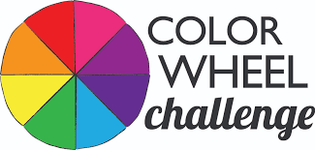

Find brightly colored objects around your house
and create a Color Wheel or Rainbow.
Place the objects in color order and take a photograph of it.
Upload your photo to Mrs. Avery’s FlipGrid.

Directions on how to use the FlipGrid
1. Click the link https://flipgrid.com/averysayhello
2. Click Log in with Microsoft
3. Type in your student email address.

(Your student email address is “yourlunchcardnumber”@fcstu.org.)
Example: 2000123456@fcstu.org.
It’s the same number you use for ClassLink.

