MATH &HEAT Choice Board
SELECT 5 ACTIVITES FROM below to complete this week.
The math graphing quiz and I-Ready Math must be two of your selections!
PICTURE IT!  Make a poster using the following Heat vocabulary. Use words, pictures, symbols.  Heat, thermometer, temperature, insulator, conductor/conduction, energy, friction | SUPER CHALLENGE  A NASA/Design Squad Challenge.  FEEL THE HEAT! | LAB 1 INSULATORS  Click on the LAB 1 button to bring up the experiment. Make sure your parent(s) help- out.  Complete the write up for the experiment on the back of the Lab sheet.
LAB 3 COLD HANDS  Click on the LAB 3 button to bring up the experiment. Make sure your parent(s) help-out.  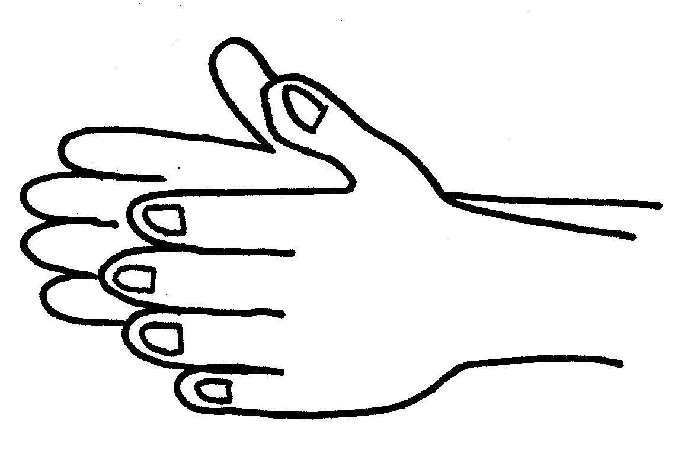  Complete the write up for the experiments on the back of the Lab Sheet. | MATH WORKSHEET  TEMPERATURE CHANGES  Complete the math worksheet on thermometers and temperature changes. | GRAPHING QUIZ  Take this Graphing quiz. It will be a paper and pencil quiz. When you finish, please have your parent(s) take a picture and send it to your teacher.
I-READY MATH  Go to I Ready Math and complete 2 lessons this week. | LAB 2 Absorbing Heat  Click on the LAB 2 button to bring up the experiment. Make sure your parent(s) help-out.  Complete the write up for the experiment on the back of the Lab Sheet. | TECHNOLOGY  1. Watch the 2 You Tube Videos about Heat  Conductors1  Conductors2  2. Play Quizizz by going to quizizz.com/join and enter the game codes below.  440618  131748  812149

