Online P.E. Plans for 3/30-4/3

-3 point shooting contest you can do indoors or outdoors with any equipment. Click the link below and post your results to flipgrid!

https://www.youtube.com/watch?v=sm7Q57ltRGw

-Follow along to some nfl players and cheerleaders working out. There are 4 workout videos you can click on.

https://aha-nflplay60.discoveryeducation.com/field-trip?utm_source=referral&utm_medium=partner&utm_campaign=khc2020&utm_term=applink

-We have been working on basketball during our connections class, so here are some videos that will help reinforce those skills. If you don’t have a basket, then get creative by shooting at a target on the wall or a box on the ground.

https://www.youtube.com/watch?v=-viReV-_lOQ

https://www.youtube.com/watch?v=MRrNi7uHmaY

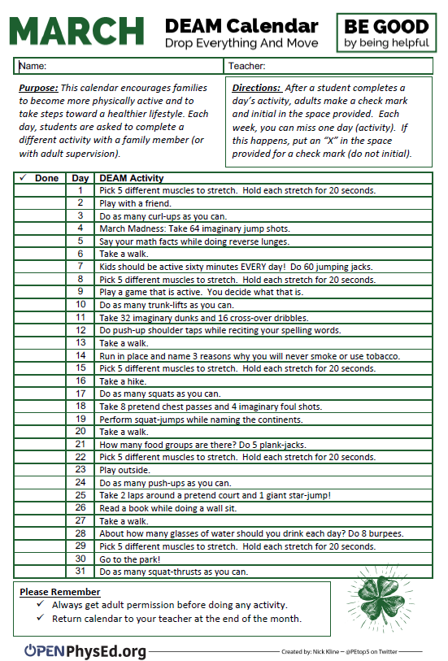
https://fultonk12-my.sharepoint.com/:w:/g/personal/finnm_fultonschools_org/EYLUOIubdeVFky9wSTYhobEBW44vikwn0jaAYGoZwxNsww?e=4%3AzKpib5&at=9&CID=9eea66ce-1877-b727-040b-03346f2c2d89

