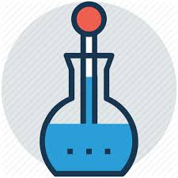
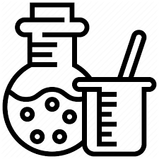
Science Lab Report

Experiment: What Absorbs More Heat?
The more light the object absorbs, the more heat absorbed since light is energy.

Materials:  2 identical drinking glasses.  Water  Thermometer (optional)  2 rubber bands or tape  White paper  Black paper | Questions to Answer: If you were outside in the sun and you were wearing white clothes, would you stay cooler with white clothes or with black clothes?  Hypothesis: Which color, white or black, will keep you cooler in the summer? Write your answer below, then you can test your hypothesis.

Steps:
1.Take the white paper and wrap it around the glass, use a rubber band or tape to hold it on.
2.Take the black paper and wrap it around the other glass, use a rubber bad or tape to hold it on.
3.Fill both glasses with the same amount of water.
4.Leave the glasses with water outside in the sun for 3 hours.
5.Each hour test to see which water is warmest. If you don’t have a thermometer, use your finger.
Results: Answer the following questions.
Did your temperatures change hourly? (if you didn’t have a thermometer you used your finger)
What color should you wear in the Summer to stay cool? Why?

