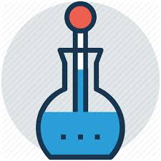
Science Lab Report

Experiment: Cold Hands
Friction occurs when two surfaces move over each other. Air resistance and water resistance are friction forces caused by the movement of something through the air or the water.

Materials: your hands, your arms and your legs! | Questions to Answer: For our experiment today, think about what happens when you rub things together.  Hypothesis: When you rub them together, will your hands, arms or legs get warmer faster? Write your answer below, then you can test your hypothesis.

Steps:
1.Make sure your hands are cold.
2.Put your hands together and start rubbing them slowly. Then start rubbing them together really fast.
3.Next, try rubbing your hands up and down your thighs really fast.
4.Try crossing your arms and rubbing your hands up and down the tops of your arms really fast.
5.Try holding your breath and rubbing your hands together.

Results: Answer the following questions.
When you rubbed your hands together faster what happened?
What did you notice when you rubbed your hands up and down your thighs?
How about when you crossed your arms and rubbed them?
Did you notice anything when you held your breath and rubbed your hands?

